DEV/TRACK

Track- UI/UX 41

Project Title- IPL Seat Saver

Team Members- Vidhi Dattatraya Kamat (R22EH144)

-Pramod A B(R22EF154)

-MN Kavya(R22EK041)

-Harini N Kulkarni(R22EJ023)

Scrum Mentor- Prajna Patil

Problem Statement

To develop a user-friendly and feature-rich desktop application for the Indian Premier League (IPL) that will help us to find consolidated and up-to-date information on matches, players, teams, and statistics. It will simplify the process of accessing comprehensive data and updates in real-time.

Introduction

Cricket in India isn't just a sport; it's an emotion, a celebration, and a way of life. The Indian Premier League has redefined the way we experience cricket, with its high-octane matches, iconic players, and an atmosphere that unites millions of fans worldwide. IPL has a global fan base, and the app should cater to users with different language preferences and accessibility needs.

We are thrilled to introduce you to the IPLSeatSaver application, your go-to companion for an exhilarating cricketing experience.

From accessing real-time match scores and player statistics to booking tickets for the next thrilling encounter, this is your gateway to an immersive and interactive cricketing journey. Connect with fellow fans, engage in lively discussions, and stay up-to-date with the latest IPL news and updates.

Get ready to cheer, shout, and celebrate as we embark on another thrilling season of cricketing glory together.

Our approach to the IPL project is driven by a deep understanding of cricket's passionate following, a commitment to user satisfaction, and a dedication to delivering a dynamic, feature-rich, and secure desktop application.

Tech Stack

We have designed using the UI/UX Figma platform to create this application. We have enhanced the user experience.

UI Snapshots

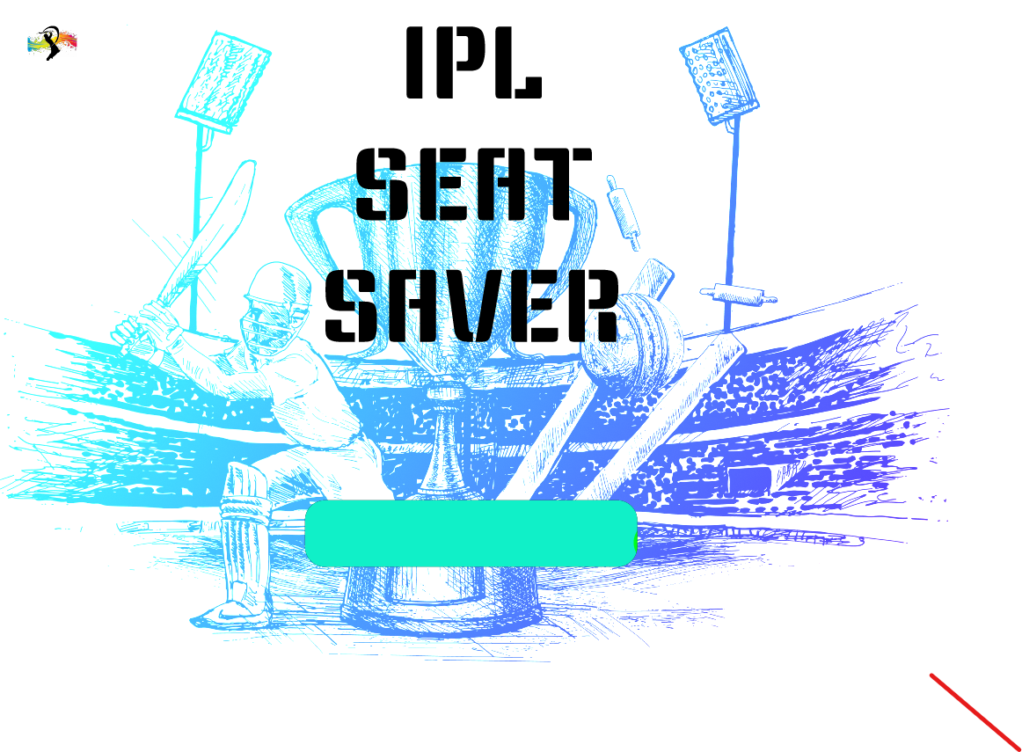 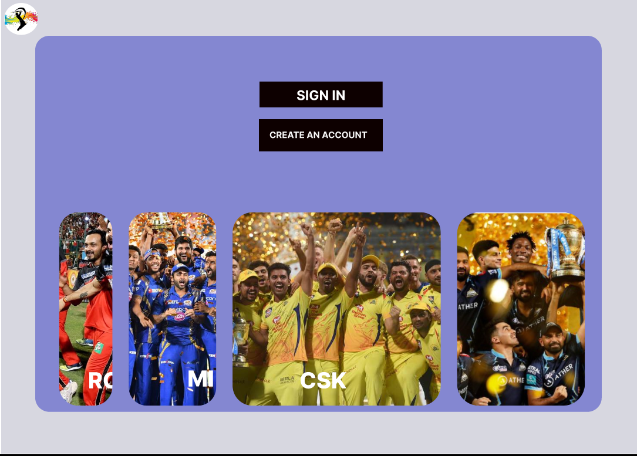

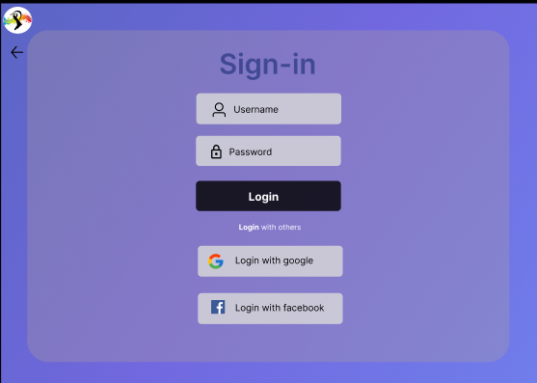 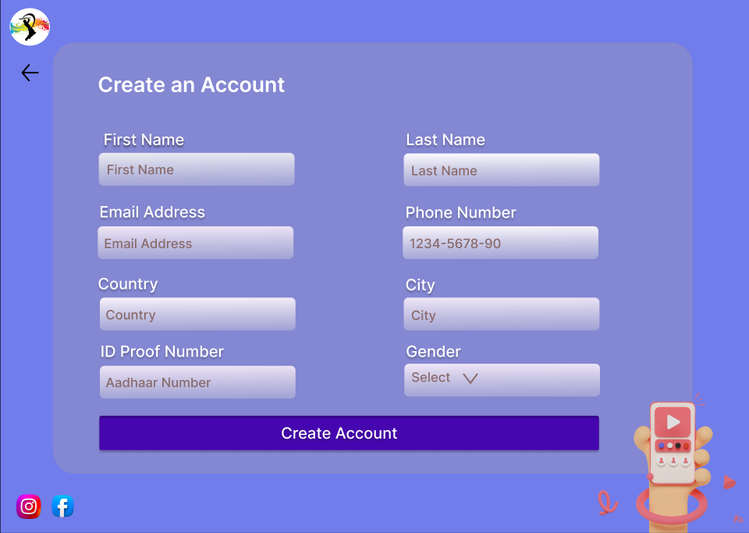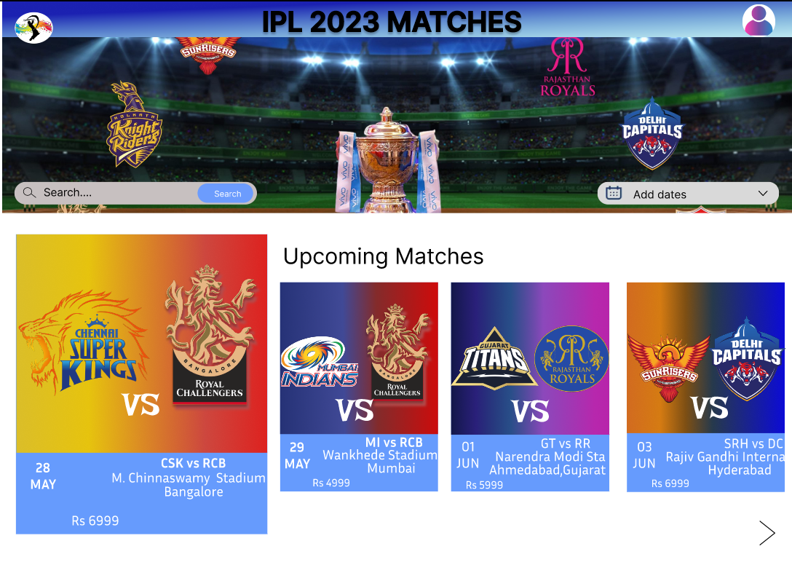 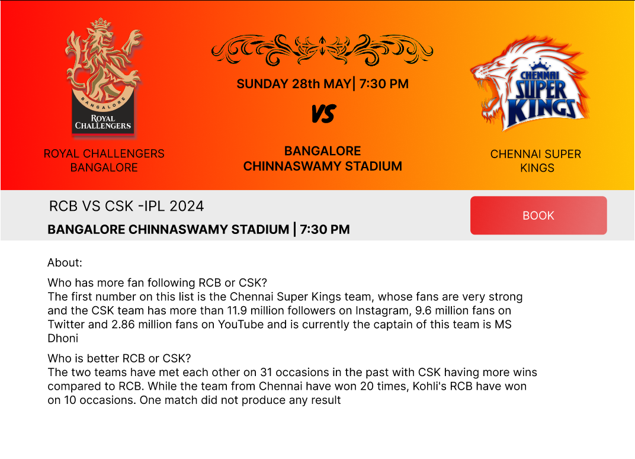

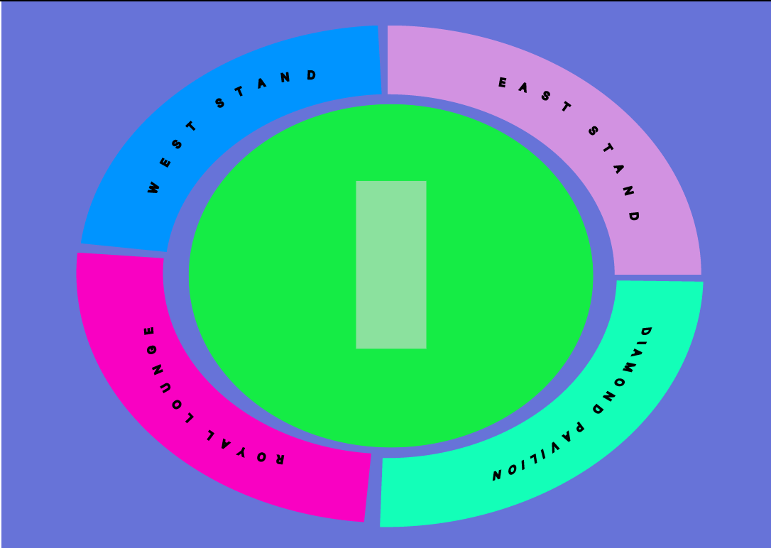 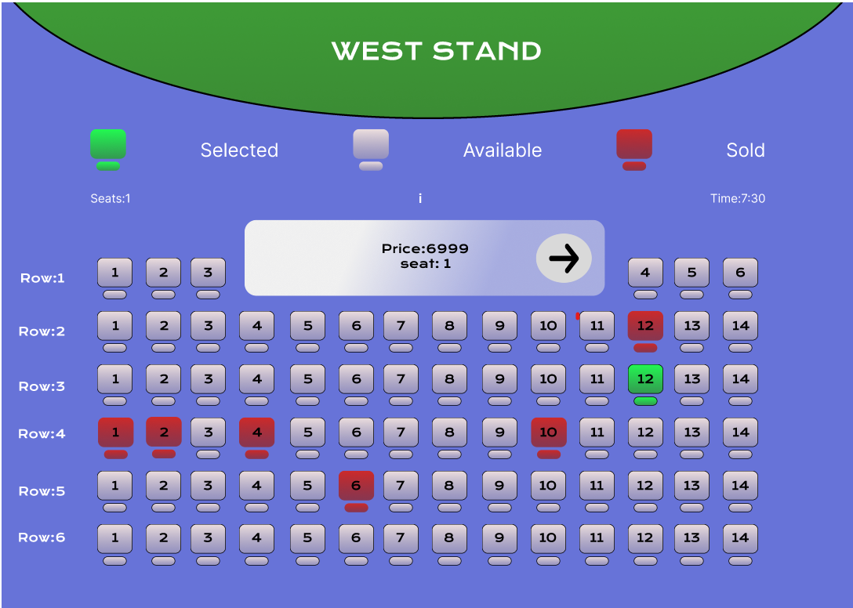

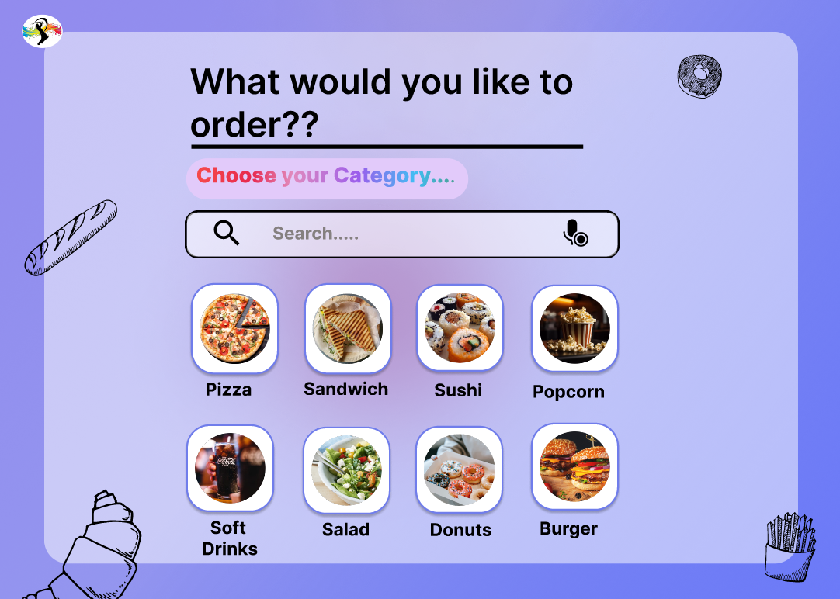 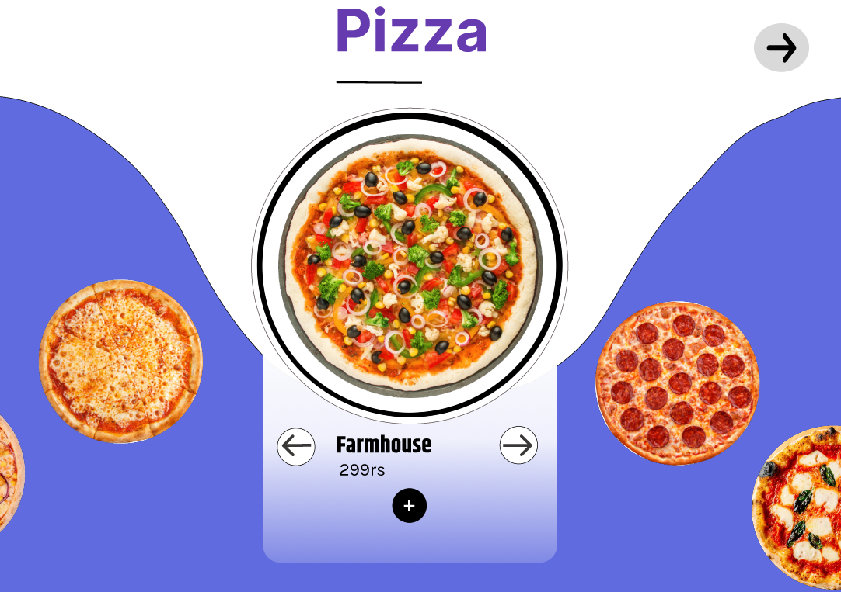

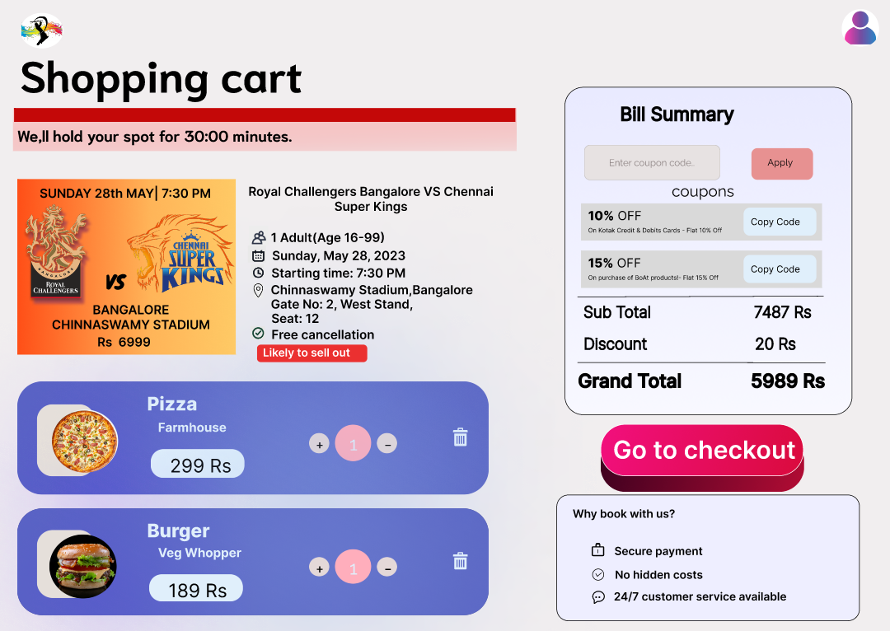 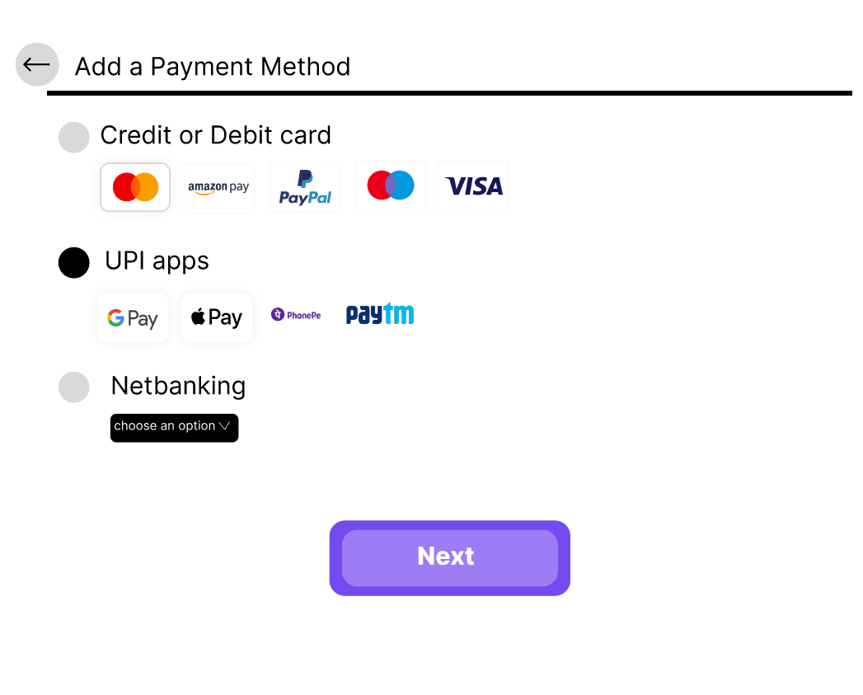

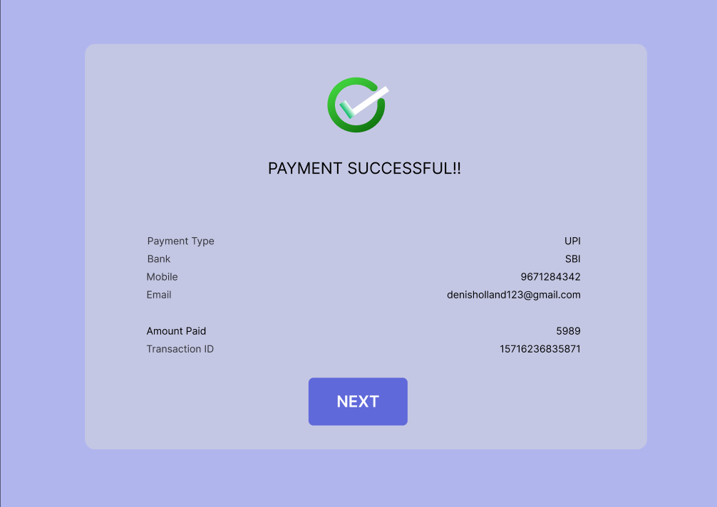 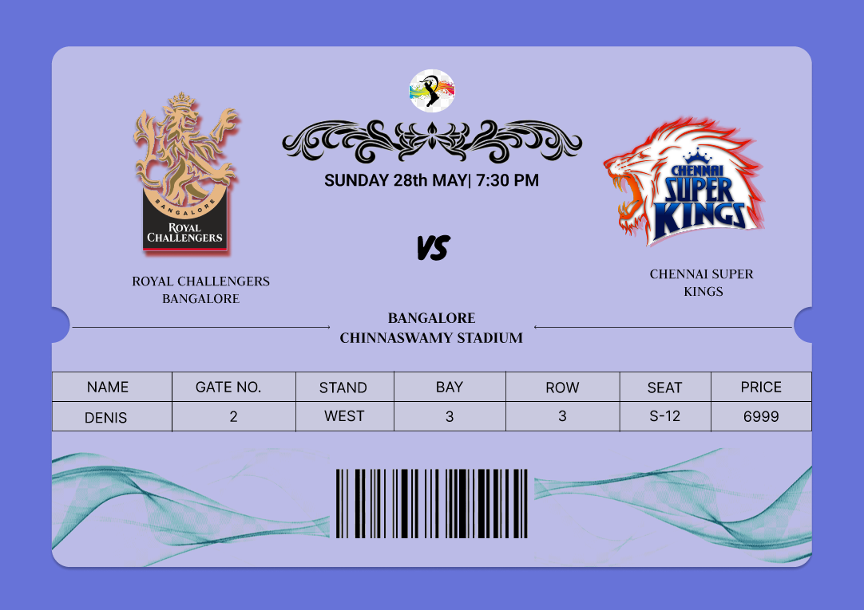

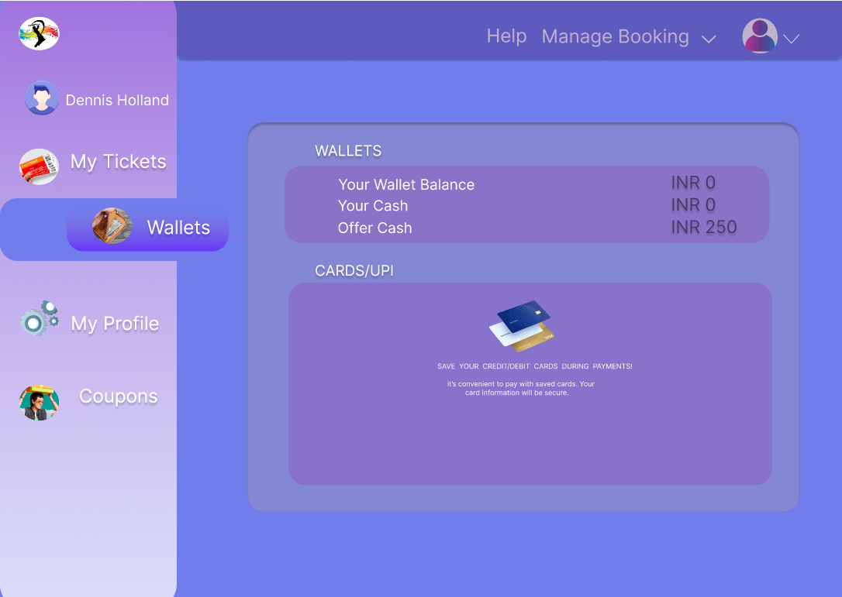 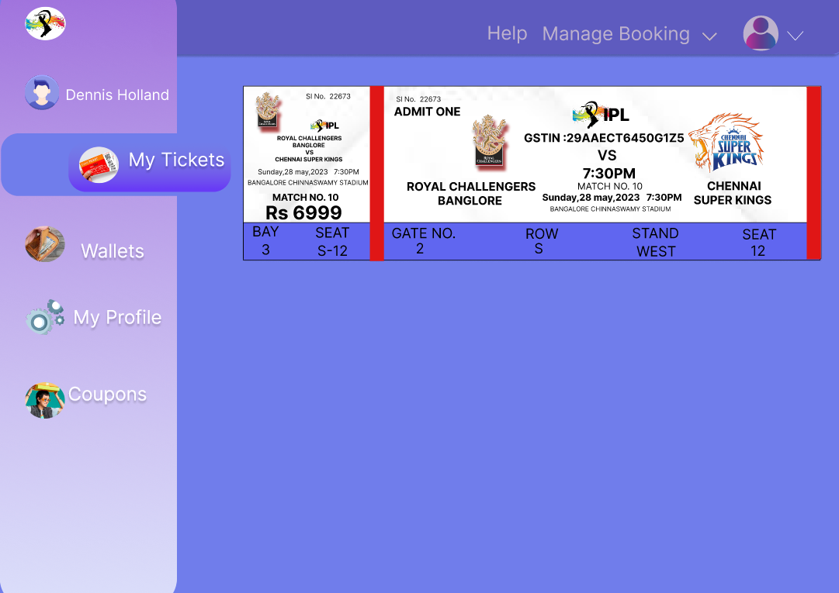

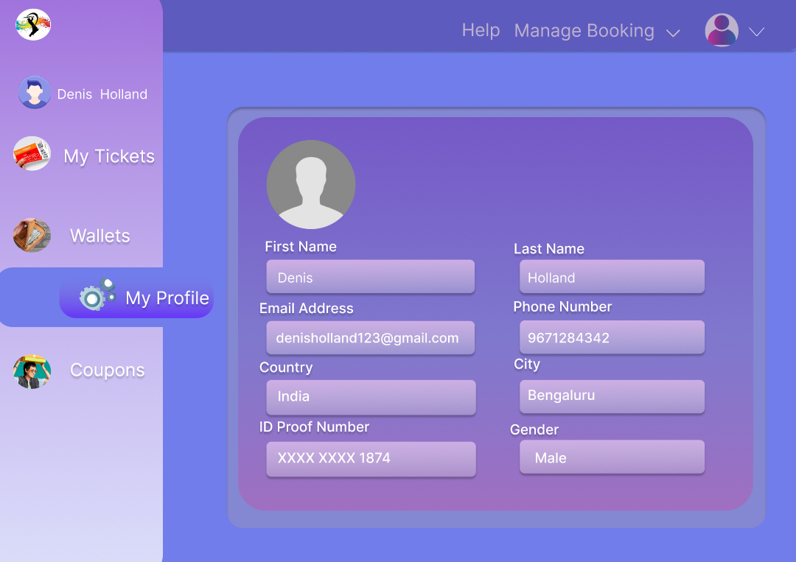 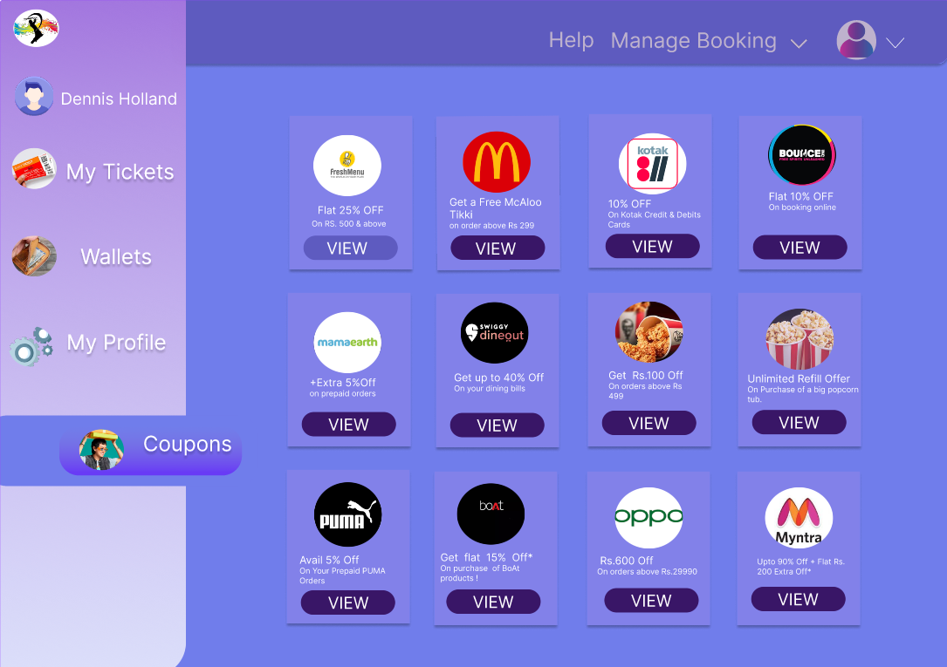

Individual Contribution

Vidhi- I tried exploring the animation effects and used different tools in figma. I have done the sign-in/sign-out layout page, create an account page, shopping cart page and the homepage that displays the upcoming matches.

Kavya- I have learnt how to create animation and use various tools in figma . I have created a basic figma profile page containing My tickets ,coupons,my wallet and my profile.

Pramod-

Harini-

Links

References:

https://in.bookmyshow.com/

https://in.bookmyshow.com/sports/india-icc-mens-cwc-2023/ET00367219